SUPPLY AND FACILITY INVENTORY MANAGEMENT SYSTEM

In partial fulfillment of the requirements in
SOFTWARE ENGINEERING 1

Leader: Wagwag, Byron Scott G.
Members:
Bondame, Sean Allen G.
Dela Cruz, Charisse F.
Husain, Stephan Yder

Bachelor of Science in Computer Science – BSCS 3D

Mr. Melchor Paz
Software Engineering 1 Professor

2. FEASIBILITY STUDY
2.1. Technical Feasibility

The proposed system is technically feasible based on current hardware capabilities, software requirements, and infrastructure availability. This section evaluates whether the technologies, resources, and technical expertise needed for the system can be adequately supported.

A. Technology Requirements

To ensure smooth operation, the system requires modern hardware, reliable software frameworks, and secure authentication technologies:

1. Hardware Requirements

RAM: Minimum of 8GB to handle system operations and large datasets efficiently.

Processor: Intel i5 or higher to ensure fast processing of user requests and data queries.

Storage: At least 500GB SSD for fast system boot times, data retrieval, and secure storage of user records.

Network: Stable and reliable internet connection for cloud-based or multi-user environments.

Backup Power: UPS to prevent data corruption or loss during unexpected power interruptions.

2. Specialized Technologies Needed

Biometric Scanners (if applicable): For environments requiring biometric verification in addition to traditional login systems.

Database Servers: To store user credentials, login logs, roles, and related system data securely.

Web-Based or Mobile Platform: The system can run on modern browsers or mobile devices to allow flexible accessibility.

Secure Identity Management: Use of hashing algorithms such as bcrypt or Argon2 for secure password storage.

B. Software Requirements / System Features

The system will rely on modern software technologies to ensure security, reliability, and usability.
Key features supporting technical feasibility include:

Module 1: Registration & Login System

Registration Features

Admin Approval for New Accounts
Only accounts validated and approved by an administrator are allowed system access.

Role-Based Access Control (RBAC)
Users are assigned roles (Admin, Staff, Viewer), restricting functionalities based on responsibilities.

Duplicate Registration Prevention
The system automatically checks existing email, employee ID, or national ID to avoid duplicate accounts.

Login Features

Password Verification
Authentication uses securely hashed passwords with industry-standard hashing algorithms.

Account Status Check
The system verifies the user’s activation and approval status before access.

Login Attempt Limiting
Failed login attempts are limited to protect the system against brute-force attacks.

Two-Factor Authentication (Optional/Advanced)
A secondary verification code sent to email or phone adds an extra layer of security.

These software features demonstrate that the required technologies are available, mature, and fully capable of supporting the system.

C. Infrastructure Needs

For operational efficiency, the system requires dependable IT infrastructure, including:

Campus-wide or organization-wide network access for seamless real-time operations.

Biometric registration kiosks (if biometric authentication is implemented).

Secure servers or cloud hosting for data storage and user authentication.

Regular system backups to prevent data loss and ensure disaster recovery capability.

D. Operational Plan

The implementation approach will follow a structured deployment strategy:

Student/User Enrollment Phase
Includes user account creation, biometric registration (if used), and initial data population.

Pilot Testing
A controlled group will use the system to identify bugs, usability issues, and security concerns.

Full Deployment
After successful testing and refinement, the system will be rolled out campus-wide or organization-wide.

This step-by-step approach ensures a smooth transition from existing processes to the new system.

Risk Assessment:
- Technical Risks: System failures, cybersecurity threats, and data breaches.
- Mitigation Strategies: Regular security update, data backups, and robust authentication mechanisms.
- Operational Risks: User resistance and technical difficulties.

2.2. Economic Feasibility
To determine whether the system is financially practical, a cost-benefit analysis was conducted based on the required hardware, software features, and security mechanisms.
Estimated Costs
Development Costs
- Creation of the Registration & Login module.
- Database setup for secure credential storage (bcrypt/Argon2).
- Procurement of required hardware:
  - Minimum 8GB RAM
  - Intel i5 processor or higher
  - 500GB SSD
- Setup of network infrastructure and UPS backup system.
Operational Costs
- Network and server support for continuous system operation.
- System maintenance, including security patches, login attempt monitoring, and RBAC updates.
- Replacement or upgrade of computer hardware when needed.
Maintenance Costs
- Regular software updates to improve login security (e.g., improved hashing, 2FA).
- Fixing bugs, database optimizations, and performance enhancements.
- Routine system monitoring and backups.
Revenue / Cost Savings
Cost Savings
- Reduced manual handling of user registration and account verification.
- Less paperwork and lower administrative labor cost.
- Faster login and access processes, improving workflow efficiency.
Efficiency Gains
- Better experience for system users (admins, staff, faculty).
- Accurate and secure registration prevents duplicates and reduces errors.
- Improved security boosts institutional credibility.
Funding Sources
- University Budget Allocation – Primary internal funding.
- Government Grants – Support for digital transformation initiatives.
- Private Investors or Tech Partners – Optional funding for system expansion.
Break-Even Analysis
With reduced labor, faster operations, and lower administrative workload, the projected break-even point is 2–3 years, depending on operational savings and institutional support

Operational Feasibility
This section evaluates how well the system fits into daily operations and user workflows.
Organizational Structure
- Project Manager – Oversees system development and implementation.
- System Developers – Build the Registration & Login module and maintain system features.
- Database Administrators – Ensure secure storage of hashed passwords and user data.
- IT Support Team – Assists users with login issues, account activation, or access errors.
- Security Officers – Ensure policies like RBAC and login restrictions are followed.
Human Resource Needs
- Skilled IT specialists for system development and maintenance.
- Database administrators for secure account and credential management.
- Administrative staff who manage account approvals and user roles.
- Support personnel trained in troubleshooting login and access issues.
Process Workflows
1. Account Registration
- User submits registration form.
- System checks for duplicate email/ID.
- Admin reviews and approves the account before activation.
2. Login Process
- System verifies password (bcrypt/Argon2).
- Checks if account is active and admin-approved.
- Limits failed attempts; optional 2FA adds extra security.
3. Role-Based Access
- Users assigned roles (Admin, Staff, Viewer).
- System restricts access based on assigned permissions.
Risk Assessment
Technical Risks
- System failures or database corruption.
- Cybersecurity threats, brute-force attacks, or credential theft.
Mitigation Strategies
- Regular software updates and database backups.
- Strong authentication features: password hashing, login attempt limits, optional 2FA.
- UPS support to prevent data loss due to power failures.
Operational Risks
- User resistance to new login rules (e.g., strong passwords or 2FA).
- Difficulties during initial rollout of role-based access.
Mitigation Strategies
- Clear user training and documentation.
- Support team available for onboarding and troubleshooting.

CONCLUSION
The system is operationally feasible because the organization has the necessary personnel, technical skills, and workflow structure to support its implementation. With defined roles—from developers to IT support and security officers—the system can be effectively managed and maintained. The processes for registration, login, and role-based access fit smoothly into daily operations, while identified risks can be controlled through regular updates, strong security measures, user training, and technical support. Overall, the system can operate efficiently within the institution and meet user needs with minimal disruption.

ANALYSIS PHASE
REQUIREMENTS GATHERING

FUNCTIONAL REQUIREMENTS
1. Add User
1.1 The system shall provide a form to input new user information (name, ID number, email, gender, time-in).
1.2 The system shall allow the registration of a fingerprint ID using a biometric scanner.
1.3 The system shall validate all required fields before saving.
1.4 The system shall validate email format (e.g., user@plmun.edu.ph).
1.5 The system shall ensure each fingerprint ID is unique.
1.6 Upon successful validation, the system shall save user data to the database.

2. Update User
2.1 The system shall allow searching and retrieving existing user records.
2.2 The system shall allow editing user information.
2.3 The system shall re-validate updated information before saving.
2.4 The system shall store all validated updates in the database.

3. Remove User
3.1 The system shall provide a delete option for each user record.
3.2 The system shall request confirmation before deletion.
3.3 The system shall permanently remove the user record after confirmation.

4. Display Users Table
4.1 The system shall display all user records in a table with relevant fields.
4.2 The system shall load records dynamically using AJAX for real-time updates.
4.3 The system shall refresh the users table every 5 seconds.

5. Input Validation
5.1 The system shall validate all form inputs before saving or updating.
5.2 The system shall ensure fingerprint IDs follow the correct format and are not duplicated.
5.3 The system shall enforce institutional email formatting rules.

NON-FUNCTIONAL REQUIREMENTS
1. Performance Requirements
1.1 Users Table must load within 2 seconds on standard connection.
1.2 System must support 100 concurrent users without lag.
1.3 AJAX refresh must complete in under 5 seconds.

2. Usability Requirements
2.1 Interface should be easy to use and require less than 3 minutes of user training.
2.2 System shall support accessibility (WCAG 2.1 Level AA).

3. Reliability Requirements
3.1 System shall maintain 99.5% uptime monthly.
3.2 System shall recover from crashes within 30 seconds.
3.3 Data integrity shall be preserved through transaction-based commits and UPS support.

4. Security Requirements
4.1 All admin actions (Add/Update/Delete User) require authentication.
4.2 All data transfers shall use HTTPS (TLS 1.2 or above).
4.3 Fingerprint data shall be securely stored using encryption or one-way hashing.

5. Maintainability Requirements
5.1 Codebase shall be modular and well-documented for ease of updates.
5.2 Database schema shall support versioning for future modifications.

6. Compatibility Requirements
6.1 System must support Chrome, Firefox, Edge, and Safari.
6.2 System must be responsive across desktop, tablet, and mobile devices.

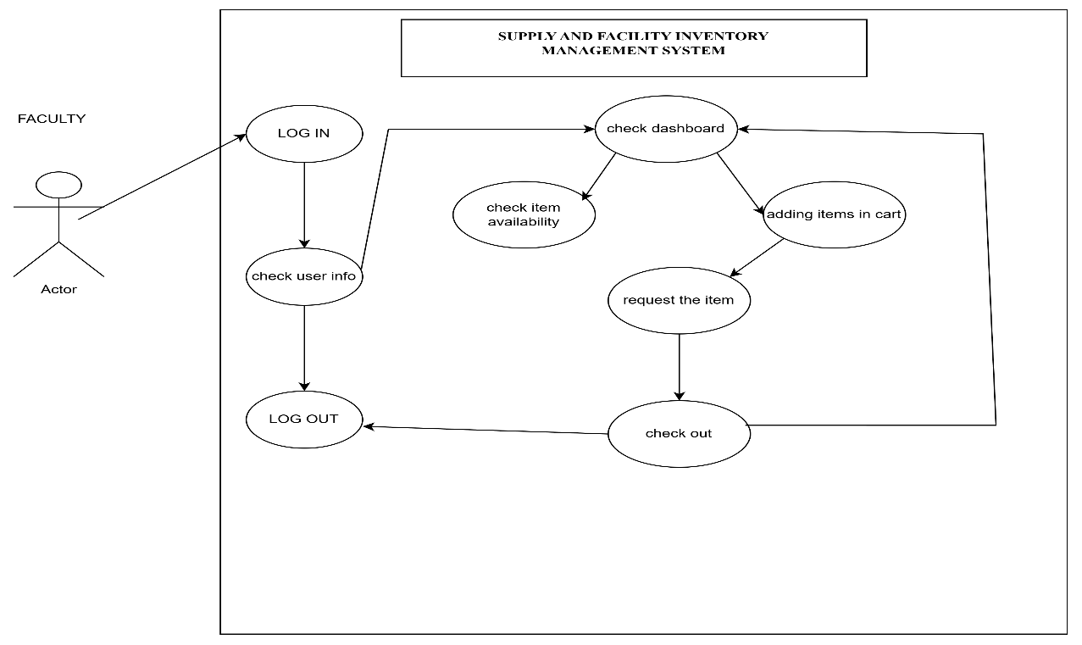

Figure 2

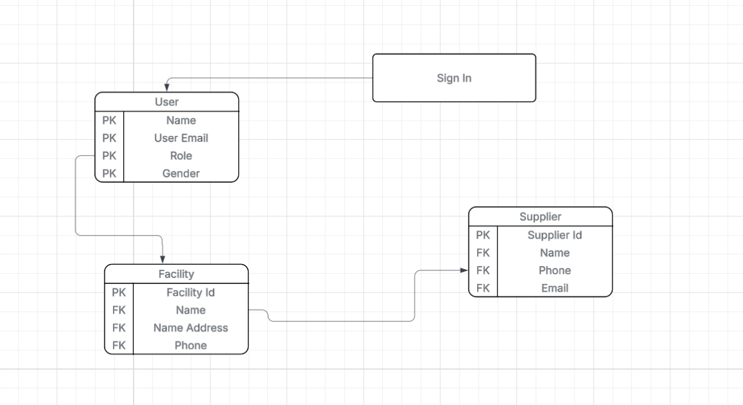
Figure 3

REFERENCES
Netsuite. (2020, August 26). Must-Have Inventory Management System Features, Requirements & Modules. Netsuite. https://www.netsuite.com/portal/resource/articles/inventory-management/inventory-management-system-features.shtml TeacherLists. (2022-2023).

TeacherLists reports a 32% increase in the cost of the most common supplies requested by teachers and schools on the 2022-2023 back-to-school school supply lists. TeacherLists. https://www.teacherlists.com/blog/teacherlists-reports-a-32-increase-in-the-cost-of-the-most-common-supplies-requested-by-teachers-and-schools-on-the-2022-2023-back-to-school-school-supply-lists-mid-season-update/

